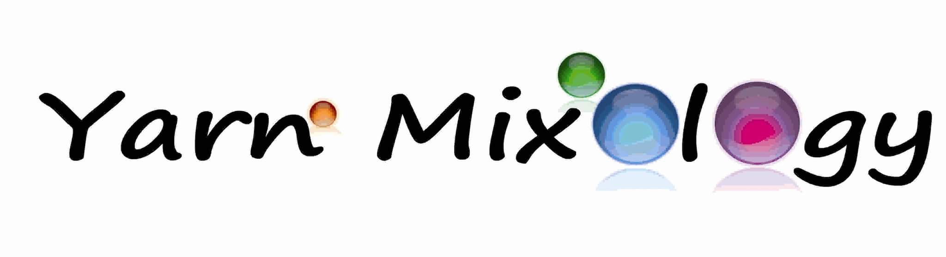
Mix and Match Shawl
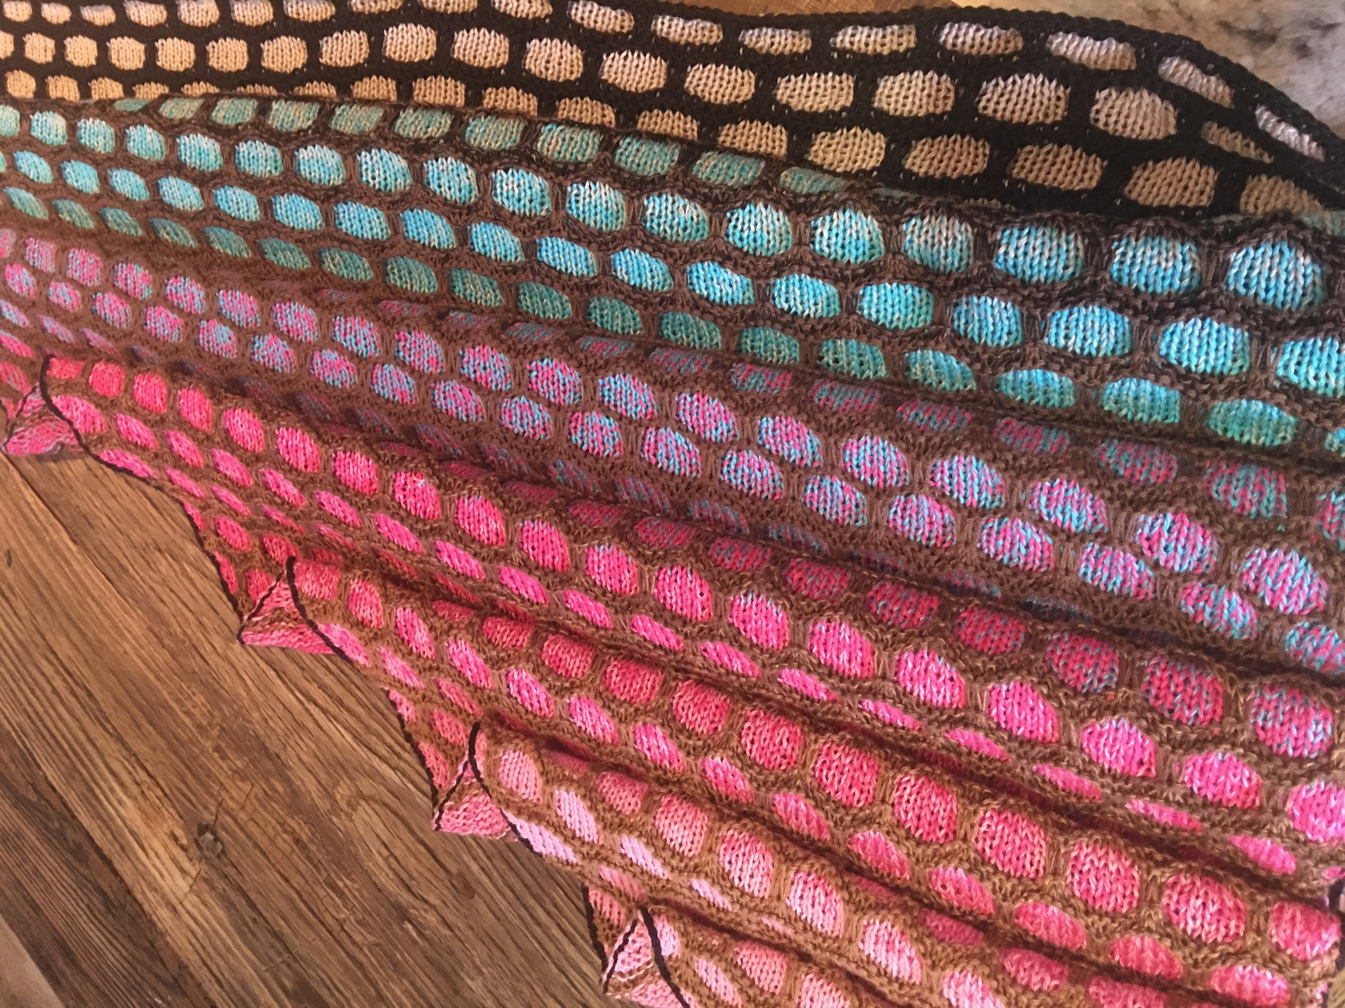

Featuring a Honeycomb pattern
You need: 2 Mix and Match bobbles (or 2 full size bobbles for an XXL shawl)
Knitting needles size 3.25mm -3.5mm
Crochet hook size 3
Needle to weave in the 4 strands at the end

Abbrevations:
K = knit
P= purl
SL2 = slip 2 stitches. At the RS of your piece, the yarn will be at back. At the WS of your piece, the yarn will be at the front.
KFB = increase one stitch by knitting into the front AND back of your stitch
K2TOG = Knit 2 together.
WS = wrong side of the fabric. That’s all even row numbers (2, 4, etc)
RS= right side of the fabric. That’s all odd row numbers (1, 3, etc)
A few things before we start:
- Just like the Mixology Shawl, the Mix and Match Shawl is an asymetrical triangle. The increases are on only one side of the piece. Each increase is worked at the beginning of each WS row.
- This shawl NEEDS to be blocked. Blocking opens up the pattern and the shawl increases in size by about 25%, depending on how you block it. At the end you have a lovely, cosy fabric.
- You only ever knit with ONE colour, so no need to feed the unused yarn along. This makes for very quick and neat knitting. You knit 4 garter rows with the contrast colour (that’s the colour you see as the honeycomb on top) and 6 stockinette rows with the main colour. The unused colour just stays at the beginning of the RS row. When you change colour, just gently pull up the new colour. If it is not too neat looking, don’t worry. At the end, you’ll frame the entire shawl in a row of crochet slip stitch.
- You’ll notice that I am not suggesting any edge stitches to the rounds. The reason is that you’ll crochet around the shawl at the end, so there is no need.

Let’s start!
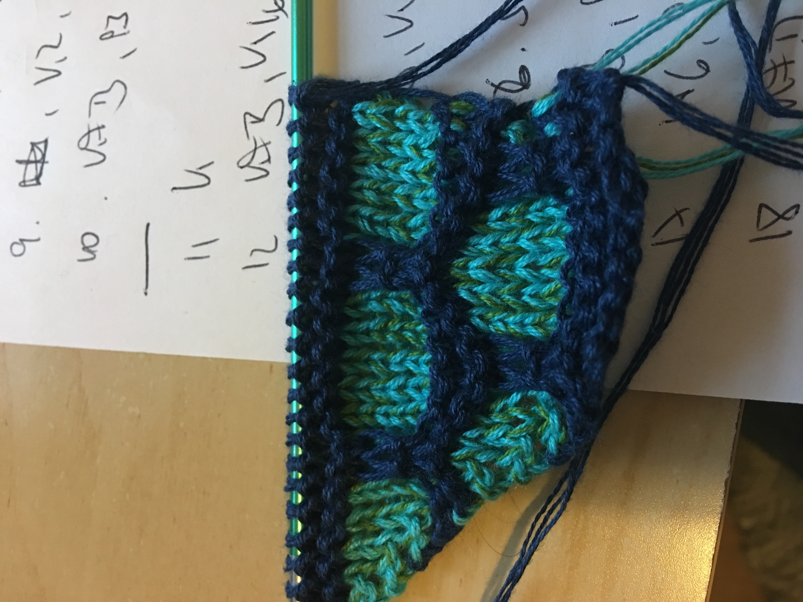

With Contrast Colour, cast on 12 stitches
Row 1 – K12
Row 2 – KFB, K to the end
Row 3 – K13
Row 4 – KFB, K to the end
Change to Main Colour
Row 5 – K2, SL2, K6, SL2, K2
Row 6 – KFB, P1, SL2, P6, SL2, P2
Row 7 – K2, SL2, K6, SL2, K3
Row 8 – KFB, P2, SL2, P6, SL2, P2
Row 9 – K2, SL2, K6, SL2, K4
Row 10 – KFB, P3, SL2, P6, SL2, P2
Change to Contrast Colour
Row 11 – K to the end
Row 12 – KFB, K16
Row 13 – K18
Row 14 – KFB, K18
Change to Main Colour
Row 15 – K6, SL2, K6, SL2, K3
Row 16 – KFB, P2, SL2, P6, SL2, P6
Row 17 – K6, P2, K6, P2, K4
Row 18 – KFB, P3, SL2, P6, SL2, P6
Row 19 – K6, SL2, K6, SL2, K5
Row 20 – KFB, P4, SL2, P6, SL2, P6
Change to Contrast Colour
Row 21 – K22
Row 22 – KFB, K to end
Row 23 – K to end
Row 24 – KFB, K to end
Repeat Rows 5 – 24, slipping your 2 stitches after every 6 stitches, as you increase your width.
Carry on knitting until you get to near the end of your main colour and you are at the end of your main colour repeat (row 10 or row 20). You should have about 25g of your Contrast Colour left.
With Contrast Colour
Row 1 – K2, K2TOG, K6, K2TOG, K6, repeat to the end
Row 2 – K to the end
Row 3 – Cast off (not too loose)
When you have just one stitch left, transfer the last loop onto your crochet hook. With the right side facing you, work one round of slip stitches all around the shawl. When you arrive at the beginning, snip yarn and weave in the ends.
Soak in lovely fabric conditioner (or whatever you prefer), wring very gently. Then block to the desired size, let it dry, unpin and get ready to smile when the compliments flood in!!!

